3rd Class Home Study (2 week plan)
March 30th- April 10th

Hello boys and girls from 3rd class,
We hope you and your families are keeping well. All the teachers really miss school and are looking forward to seeing you all back in the classroom soon! In the meantime:

* Remember you can send photos of your work to cmsscreative@gmail.com
* Check out the school website www.centralmodelseniorschool.ie to listen to storytime by Ms Kildee, quiz time with Ms Brady and many more activities to come!
* Choose from any of the following activities. You don’t have to complete all the work, just do a little bit each day:

LITERACY
- Learn how to spell 5 words a day from the list below.
- Make 5 sentences a day from the list below. In your sentences, be sure to use adjectives ( Describing words)
about | across | afraid | afternoon | age
ago | almost | also | anyone | anything
balloon | basket | bean | bear | behind
birthday | blind | body | born | boxes
bread | breakfast | brush | build | buses
butter | carries | caught | change | cheese
cherry | circus | classes | clear | climb
clown | colour | coming | crawl | crazy
cries | dinner | doctor | doesn't | dollar
done | driving | early | easy | everyone
everything | eyes | finish | flies | foil
food | forgot | Friday | front | funny
gift | grinned | guess | half | happen
heard | heart | heavy | hello | himself
horse | hurt | I'll | I'm | I've
isn't | it's | kept | key | knee

- Continue with Read At Home/DEAR time book each day.

- Fact File
- In your copy, do a fact file on someone you look up to (footballer, parent, doctors and nurses, actress, singer, band)
- These are your headings;
- Name
- Age
- Why I look up to them
- Profession
- Where they are from
- Where they currently live
- What qualities do they have (kind, brave, courageous etc.)
Letter:
Write a letter to grandparents or other relatives who you can’t see at the moment (if you’re worried about going to post it etc. take a photo of the handwritten note and send it by message/WhatsApp or email and ask them to write back by letter too)
- Please select a book and read it to a younger brother or sister, or read it aloud to yourself. Find any new words and write them down.

- Dolch word lists can be googled.. Read and practise spelling the dolch words, working your way through the lists.starting at list 1. Test yourself on the spellings. Look, say, cover, write, check. Select three of the words and put them in a sentence. Write the sentence and draw a picture to go with it.

MATHS

- Mathletics - don’t forget your login details
- Continue with Mental Maths each day
- Tables:Practise your multiplication tables
- https://ie.ixl.com/math/class-3

- Login to https://my.cjfallon.ie/ .
Click on student resources. You will be asked for your name and email address
Click on 3rd class
Click on Maths
Click on Busy at Maths
Click on Busy at Maths 3rd class
Open the online book as shown below
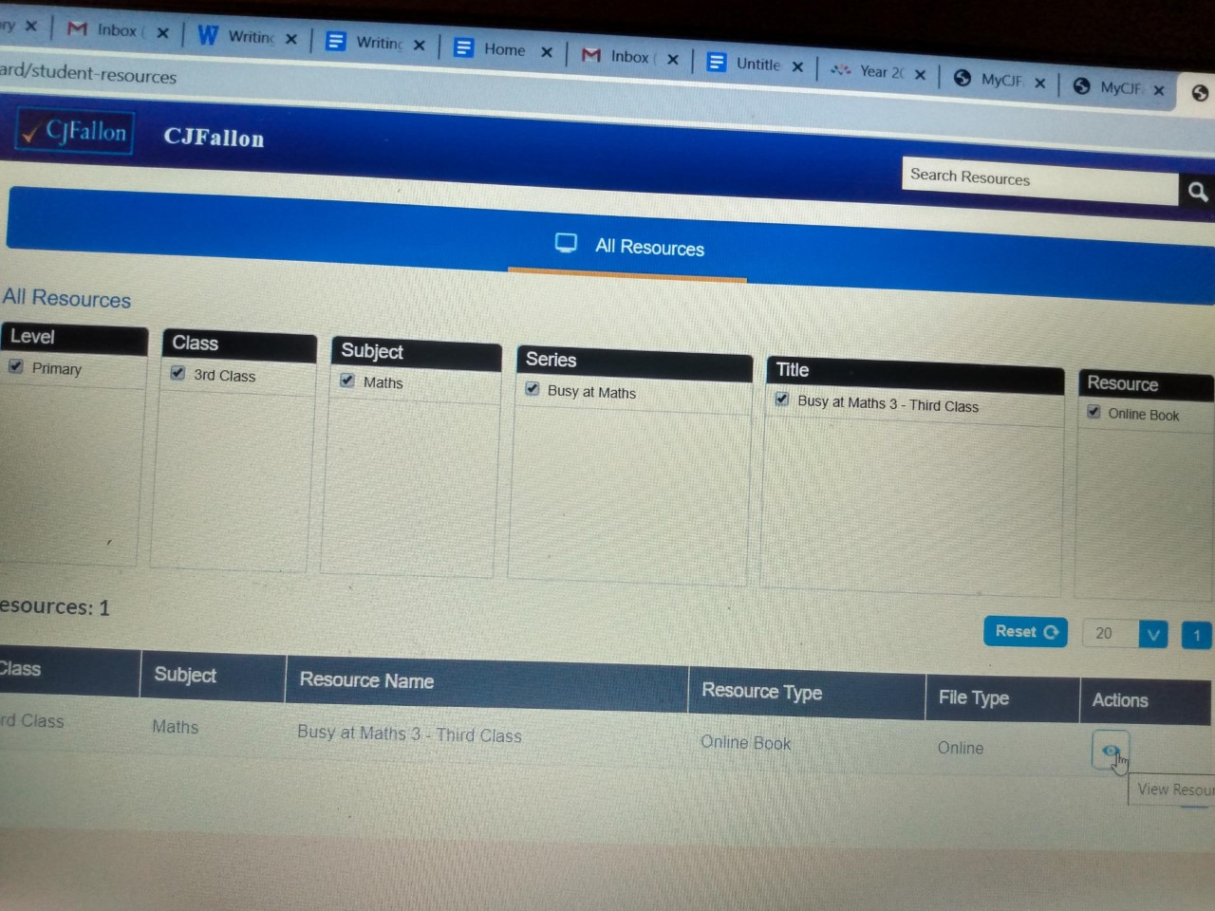
Complete chapter 18, pages 97-101
Complete chapter 23, pages 123-126

- Numberock on youtube. Go to youtube and type in Maths songs by Numberock. Alternatively use the 30 day free subscription to Numberock.com

Children please sing and dance along to these videos; Give it socks and try learning your tables as you sing and dance.

Skip counting by 10 song for kids.
Skip counting by 5 song, multiples of 5 plus Skip counting by 5 rap for kids.
Skip counting by 2 song.
11 times tables song/ skip counting the multiples of 11.

Addition with regrouping 2 digit song.

Subtraction with regrouping song/ rap for kids.

Even and odd numbers song for kids.

if you master this then here's some more ;

Skip counting by 6 rap song dance the 6 times tables.

Skip counting by 7 song with multiplication.

9 times tables song skip counting by 9 with multiplication.

Place value song for kids ones, tens and hundreds.

- Work with money at home.

Get mum and dad to give you whatever coins they have around the house.
Set up a little shop for yourself. You could be the shop keeper or the customer. Play with your brothers or sisters, if they are old enough. Use items from around the house as make believe buy and sell stock. Have a clothes shop, book shop, toy shop or food shop, whatever you decide. Give your items prices and have your customers come and buy. Calculate total prices and change for the various items they select. Have lots of fun in your very own shop.

If you are really adventurous you could bake some cookies to sell in your shop. No putting pressure on adults to help with this though.

- Measure.
Get a ruler or tape measure and measure what 2 metres looks like. Now practise keeping your distance.

GAEILGE
- Learn/revise amhrán na bhFiann https://www.youtube.com/watch?v=QV7lGmgFovM
- Learn/revise cup song in Irish https://www.youtube.com/watch?v=BhIw_qwrrpE

Practice answering and asking these 6 questions with someone at home

1. Cad is ainm duit?
_______ is ainm dom.

2. Conas atá tú?
Tá mé go maith

3. Cén aois thú?
Tá mé naoi mbliana d’aois

4) An maith leat scoil?
Is maith liom scoil

5) Cén scoil ina bhfuil tú?

Tá mé ag freastal ar Central Model Senior School/An Modh Scoil Láir Sinsir
6) Conas atá tú?
Tá mé go maith
Write 5 sentences about the food you like e.g. Is maith liom cáca milis.

P.E
- Being inside doesn’t mean you can’t be active! Get moving with some of these videos!

https://www.youtube.com/watch?v=d3LPrhI0v-w

https://www.youtube.com/watch?v=SbFqQarDM50

Get a football and practise kickie uppies. See if you can improve on your previous day. Record your personal best, to compare with your friends on return to school.

SOCIAL, ENVIRONMENTAL AND SCIENTIFIC EDUCATION (SESE)

- Project work: research 5 countries in Asia under the following headings. Use the following example to guide you. I have answered the first two questions for you.

1)Country- China
2) Capital city- Beijing
3) Draw the countries flag-
4)Popular food-
5)Popular sport-
6)Famous person-
7)Famous building-
8) Draw a famous building-
9) Countries population-
10)Name 2 other countries that are beside China

Some examples of countries in Asia include - Mongolia, India, Pakistan, Thailand, Japan, Philippines, Vietnam, Singapore, South Korea, Bangladesh, Sri Lanka & Malaysia.

Famous Inventor:
Pick a famous inventor who inspires you, write about their life, their invention and how it helped/changed people’s lives.
Examples: Alexander Graham Bell, Mary Anderson and Steve Jobs

Put together a diary of your thoughts about what is happening at present ,as a primary history resource, for your children to read.

SPHE
- Write and draw 10 examples of something you look for in a friend e.g. kindness

- Draw 5 pictures when you are happy e.g. in school, at home, at the park, in a club

- Mindfulness - practice a daily mindfulness session. Click on this link to bring you to a guided meditation session for children. https://www.headspace.com/meditation/kids
- Draw a big heart, write in all the ways you can be kind to yourself.
- Practise tying your shoelaces twice a day. See if you can master this skill, before returning to school.
- https://www.youtube.com/watch?v=VA4AACzlhe8

ART

Draw your own spring drawing. Use the video to help you https://www.youtube.com/watch?v=Z1U8hoYHVzA

Draw your own landscape drawing. Use the video to help you https://www.youtube.com/watch?v=deRPjVSpwXI

Draw scenes from the book you’re reading

Make a miss you card, a get well card or an Easter card for a relative or friend who may be self isolating or who is unwell.
Find some pebbles or shells on the beach or in the park and paint them.

Music
Learn the song Solsbury Hill
https://www.youtube.com/watch?v=uRQIic97g6U

Draw a picture of what the song means to you

Learn all about the instruments of the orchestra:
https://www.classicsforkids.com/games.html

T.V
From Monday 29th March the station RTE are televising a school hub between 11 o’clock and 12 every day. It might be worth watching

