Home Study 2
(2 week plan)
Ms Crosson and Ms. Whiston
5th Class

Morning all,
We hope you and your families are all keeping well. We’re sorry not to be returning to school today, seeing you all and catching up on all your news. We have put together some more work for you to do, to help you keep busy but we do not want you to be anxious about getting it all completed, these are just suggestions. Also, If some of the work is too difficult just leave it and move on to something else. We would also love to hear from you and about how you are finding the work. If you would like anything corrected please photograph it and send it on. If anything is too difficult or if you would like extra activities, you can let us know through the email address Ms. Gartland has set up. We will be sure to reply to all of your messages while we are apart so feel free to get in touch with us through cmsscreative@gmail.com
Ms. Crosson, Ms. Tracey and Ms. Whiston
5th class are really lucky because we have the online programme seesaw. You can log onto seesaw at home and share your work with your teacher and one another. Follow these simple instructions to get started:
- Download the seesaw class app on an a smartphone or tablet
- Click “I’m a student”
- Scan your class code
- Start working and your teacher will be able to check your work before it is published for your whole class to see, have fun!
Ms. Crosson
Ms. Whiston

Please continue with these 7 daily activities:
1. Continue with your spellings, learning them and putting them into sentences.
2. Continue with your Mental Maths – one a day
3. Continue with your Tables Champion books Monday – Thursday
4. Handwriting – continue to practice your cursive writing.
5. Read At Home - one page a day and answer the questions in your homework copy.
6. Practice Daily 10 addition, subtraction, multiplication and division every day. Record your scores in your homework journal daily. https://www.topmarks.co.uk/maths-games/daily10
7. Practice Hit the Button daily and record your scores in your homework journal. https://www.topmarks.co.uk/maths-games/hit-the-button

Here are some suggested topics for you to try!

LITERACY

- The wonderful Ms. Kildee is reading a chapter of Roald Dahl’s Esio Trot everyday! Click here to watch the video.
https://www.centralmodelseniorschool.ie/post/story-time-with-ms-kildee
- Continue to keep a daily diary. it will be very interesting for you to read back on this diary in the future as a way to remember this unique time that the world is experiencing. What have you done today? How did you keep busy? What happened that was unusual? Who did you spend time with? Did something funny happen? What surprised you today? What are you looking forward to once we are back to school? Have you found a new appreciation for simple things in life such as yard time at school or being in a playground?
- Continue with Read At Home/DEAR time book each day. Start to keep a list of interesting words from these books, we can share them with one another when we are back at school.
- Play a game of Boggle online: https://classroom-boggle.com/Online-Boggle/Online-Boggle-Game-7x5-Board/
- Here is a great website to use to practise your writing skills. Here you can find ideas for all kinds of writing styles like poetry, persuasive and narrative
https://danieldevine.github.io/ditto/
- Like story podcasts? Listen to a story on Story Time. http://storiespodcast.com/

MATHS
Time and Money are the topics for this month.

Time:

Challenge yourself with this link for practicing time using analog and digital clocks

https://www.helpfulgames.com/subjects/mathematics/tell-time.html#

https://www.helpfulgames.com/subjects/mathematics/digital-clock.

This is a conversion of time activity

https://ie.ixl.com/math/class-5/convert-time-units

Time patterns:

https://ie.ixl.com/math/class-5/time-patterns

Money:
These are for adding and subtracting, multiplying and dividing money amounts
https://ie.ixl.com/math/class-5/add-and-subtract-money-amounts
https://ie.ixl.com/math/class-5/multiply-money-amounts-word-problems
https://ie.ixl.com/math/class-5/divide-money-amounts-with-decimals-word-problems
All of these are timed. If you find these too easy or too difficult, go to https://ie.ixl.com/ and you can choose a class level that suits you best. You can score your results in your Literacy copy and see if you can beat your personal best

GAEILGE

You might be finding it tricky practising your Irish at home without your teacher but don’t worry, here are lots of things that you can try.

Watch the lovely Ms. Gillespie reading you a story as gaeilge!
https://www.loom.com/share/5a60d3fb4b9247208a71e3bd04795109

You can find your Irish book and videos online!
Follow these instructions:

- Go to folensonline.ie https://www.folensonline.ie/
- Click “register”
- Click “teacher”
- Fill in your name, email and password
- Type Prim20 for “roll number”
- Then choose “5th class” and you will find your book and videos!

Go back and revise chapters we have already done.
Try chapters 1,2,3,4 for these 2 weeks. Watch the videos and comhrá (conversations). If you would like to try an activity from your book click on
“e book” (green button in the top, right hand corner) You could try some of the activities using your literacy copy or some paper at home.

We would love to see some videos of you speaking some Irish. You could record yourself talking about the weather, saying your name, where you live, describing your clothes, talking about the food you have eaten that day. You know lots of Irish! You can email these videos to cmsscreative@gmail.com
Try these questions that we have done lots of times in school

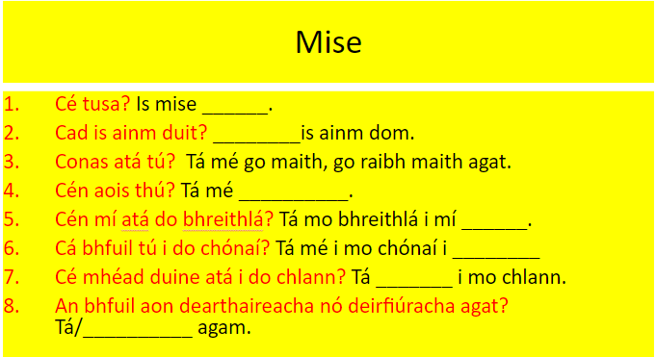

Don’t forget about our Irish songs!
Shotgun: https://www.youtube.com/watch?v=Tnznu3Jx9us
Can’t Stop the Feeling: https://www.youtube.com/watch?v=4FGr-f2EC-w
Cup Song: https://www.youtube.com/watch?v=Hz63M3v11nE

Lots of fun Irish activities that you can try at home. Bainigí sult astú!

SOCIAL, ENVIRONMENTAL AND SCIENTIFIC EDUCATION (SESE)

History

Read the facts of WW1 from the following website and answer the 10 questions below based on what you have read:

https://www.natgeokids.com/ie/discover/history/general-history/first-world-war/
Questions (answer in your copy)
- When did World War 1 start?
- How long did people think the war would last and how long did it actually last?
- Give two reasons why the Battle of the Somme is so famous
- Why were horse droppings useful?
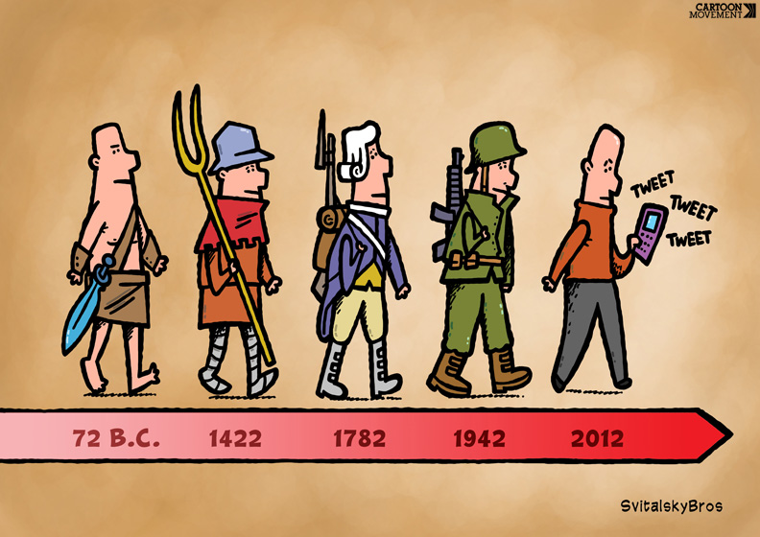
- What did the soldiers use goldfish for?
- What did women do during World War 1?
- How did children help during the war?
- Why is Sidney Lewis famous?
- What date and time did World War 1 end?
- Why is the poppy used to represent World War 1?

Bonus question:
Did you read where the idea for Winnie the Pooh came from?
Geography

Have a look at this webpage talking about Planet Earth and answer the quiz at the bottom of the page:

https://www.ducksters.com/science/earth.php

Science

Sound is our topic for this month.

We would like you to open the window, lie or sit down, close your eyes and listen to the sounds outside your window for five minutes. List all the sounds you heard, name a sound that irritated you and a sound that you could listen to all day. (Try and do this activity twice, at different times of the day)

S.P.H.E

- Keep a kindness journal - write down ways that you have been kind to people at home, or kind things that you plan to do in the future. We all (adults and children) need to try extra hard during this time to show kindness as staying at home each day is difficult for us all. Little things that you do can be so helpful to your parents. Such as, keeping your bed tidy, playing nicely with your brothers and sisters, cleaning the dishes after meal time or keeping yourself busy with some school work. We can all do something to help one another.
- Keep your rainbow diaries- write down something you’re grateful for each day. It will be lovely to read back on these when we are back at school as you may have found new things to be grateful for since school closed.
- Mindfulness - practise a daily mindfulness session. Cck on this link to bring you to a guided meditation session for children. https://www.headspace.com/meditation/kids
- Here are 2 lovely youtube videos to help you to take some relaxing, meditative time at home, find a quiet place and try them out. Maybe someone in your family would like to join in!
https://www.youtube.com/watch?v=O29e4rRMrV4
https://www.youtube.com/watch?v=bRkILioT_NA&t=57s

P.E
Being inside doesn’t mean you can’t be active! Get moving!
https://www.cosmickids.com
Joe Wicks workouts:
https://www.youtube.com/results?search_query=bodycpach+tv++classroom

Joe is also hosting a live P.E session each morning at 9am on Facebook live, these workouts are then posted to his youtube so you can have a fun workout every day!

You can download the GoNoodle app for free and in the search engine, type what music/dance genre you like and learn a dance off by heart.

Using the free Twinkl account, have a look at the fitness challenge cards to give yourself a daily workout challenge. You can pick the ones that are suited to your ability.

Don't forget to warm up and cool down properly though.
Here are some ideas to follow https://youtu.be/9y0LARZHv0E
(Warm up)

https://youtu.be/M-d11QiWdm8
(Cool down - start at 52 secs)

The sun is coming out boys and girls. Remember to get yourself out there for some fresh air every day for a short walk, following the social distancing guidelines of course!

ART

There are so many amazing artists in 5th class we would love to see some of your creations! We all might not have paint or lots of art supplies at home but we all have at least some paper and a pencil. Let’s have fun with drawing!

I will leave these ideas from the last “home study” sheet here incase you didn’t get a chance to try them

Daily Draw: each day draw one picture!
1. Draw a loaf of bread at a disco.
2. Draw a piece of fruit in outer space.
3. Draw your teacher as a zombie.
4. Draw a dragon breathing rainbows.
5. Draw a mountain topped with glitter.
6. Create your own imaginative drawing

Check out this fantastic youtube channel which will teach you how to draw lots of fun pictures!
https://www.youtube.com/user/ArtforKidsHub
Find out how to create pictures of animals using just your hand and a pencil!
https://www.youtube.com/watch?v=qJNSOte9h4I

Remember to send photos of your creations to cmsscreative@gmail.com

MUSIC

Learn the song “You’re my Best Friend” Maybe we can sing it at assembly when we are back at school!
https://www.youtube.com/watch?v=9oOHr--AMes

If you have an instrument at home, you could take up learning a new song to perform
You can learn a new song to sing
You can make your own instrument using materials you have at home
You can make up your own lyrics to a song/rap
Dabbledoo are offering parents one month free access to their materials. You can set up an account and follow the instructions to choose an activity to follow/practise
https://dabbledoomusic.com/p/parents
All ideas/photos and performances could be sent to cmsscreative@gmail.com

We hope you enjoy these activities which we have suggested. We are really looking forward to receiving photos, videos and messages via cmsscreative@gmail.com

